**Deploy Functions on Azure Function App**

1. Create Azure Function App on azure. Remember consumption plan and above function app have options to create functions in the function app through portal. For basic plan, you need to create functions through deployments only. Now, select consumption-based plan.
2. Create a repo in Azure Devops and remember below is the structure imperial (mandatory) for you to create and deploy on specific functions on function app. Else, the deployment would succeed but there would be no visible functions in the function app. 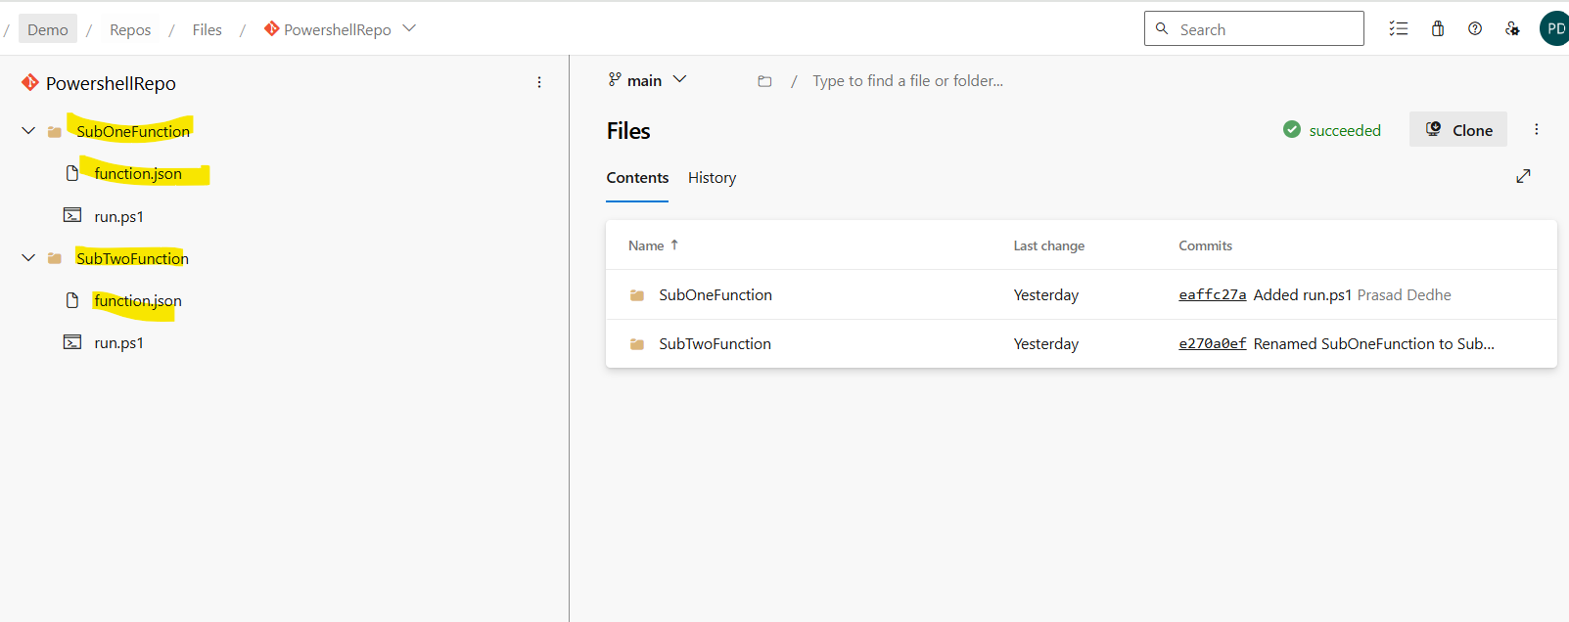
3. Then create build pipeline. (Here I am deploying a powershell script and the function app while creating was configured with the same settings) No specific settings need to be selected in this pipeline, when you search Powershell function app deploy, this pipeline would automatically populate. 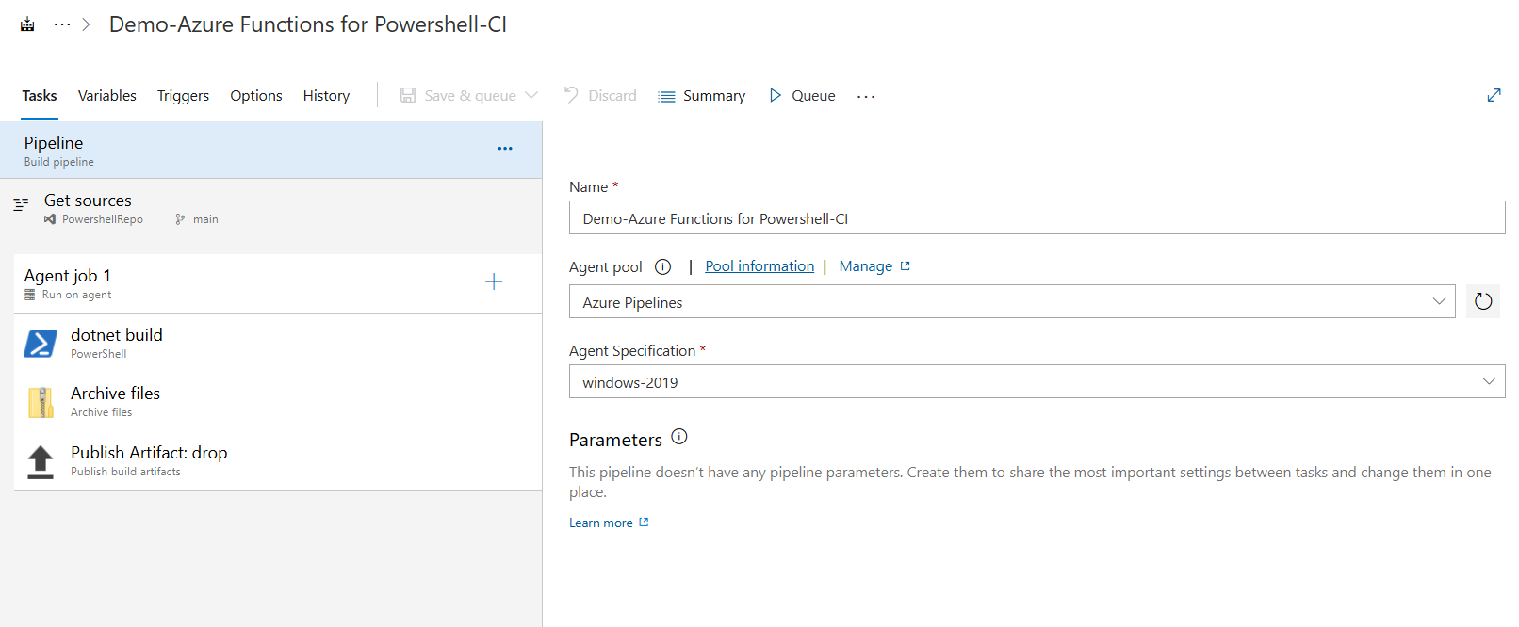
4. Create Release Pipeline. It is very simple one. First deploy and second task is to restart.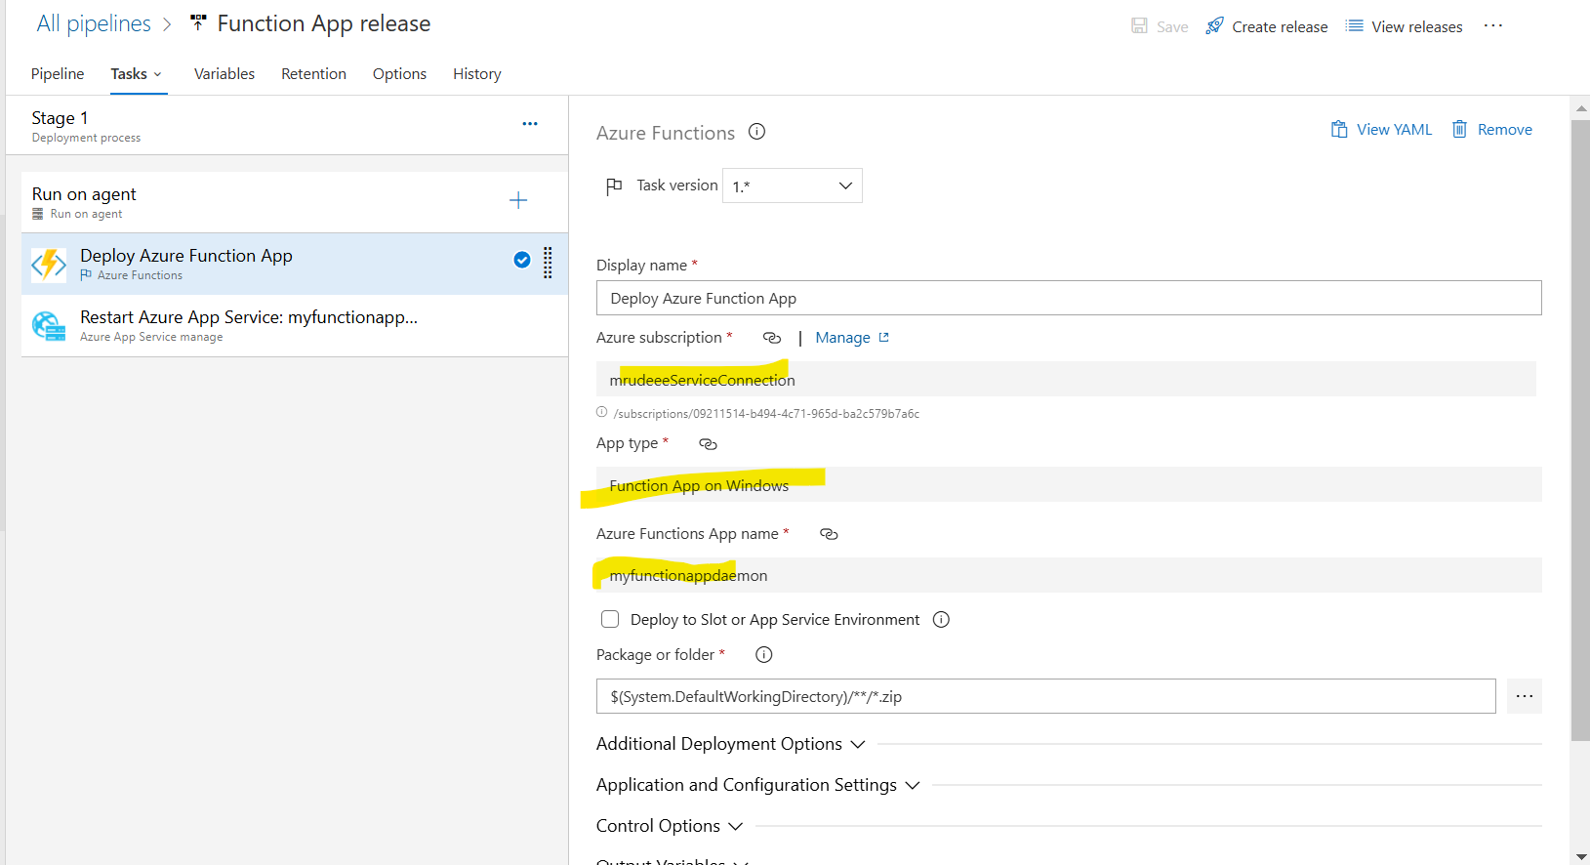
5. Deploy and you will the functions populate in the function app. 